
CERTIFICATE of DEDICATION
This certifies that
ESAHMARC E. MABANDOS
WAS DEDICATED TO GOD
At Fundamental Baptist Mission, Purok 2, Villangit, Sibagat, Agusan Del Sur.
On the 6th day of April in the year of 2025.
Father : Esaganie H. Mabandos
Mother : Mabet L. Engyo
Birthday: April 18, 2020
Officiated by: Pastor Elven B. Lumalad

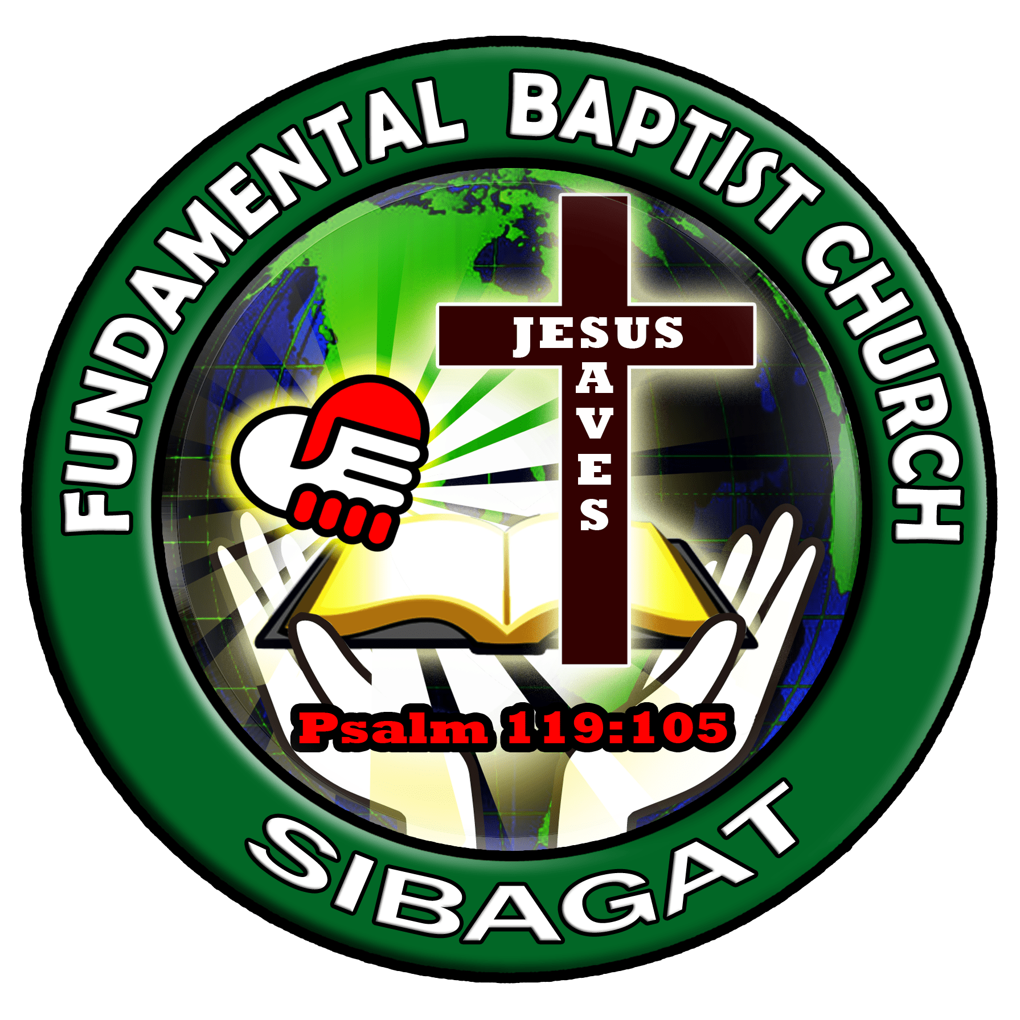
“Let the little children come to me, and do not hinder them, for the Kingdom of God belongs to such as these.”
Mark 10:14 (NIV)

